**Misleaders**

It’s best to base one’s arguments on issues and evidence. However, there are dozens of fallacies used when people discuss and debate. These are used by people we know as well as media outlets. Let’s look at a few common ones.

1. Ad hominem attack (Latin: “to the person”) – This happens when someone attacks the personality, background, etc., of an opponent instead of addressing the points of the opponent’s argument.

2. Argument from ignorance – This happens when someone says something is or can be true because it hasn’t been disproven. It’s often called “shifting the burden of proof.”

3. Argument from incredulity – This happens when someone cannot understand how a position can be true, so he/she assumes it’s false.

4. Cherry picking – This happens when a person draws a conclusion about something by looking at only a few pieces of evidence that prove the person’s point, and not looking at any contrary evidence.

5. Fallacy of the single cause – This happens when someone says that a complex event has (or had) only one cause.

6. False dilemma – This happens when someone argues that only his/her position and the opposing position are the possible choices (and, usually, that his/her own position is the correct one), ignoring any other choices.

7. False equivalence – This happens when two opposing arguments or parties are said to be the same even though they’re not.

8. Gish Gallop – This is an oral tactic named after the creationist Duane T. Gish (1921-2013). A person starts by saying a bunch of untrue things about the opponent’s position. When the opponent responds, he/she has to spend all of his/her time addressing the lies instead of talking about his/her actual position.

9. Slippery slope argument – This is a type of probability fallacy that says if one change is made, then it will lead to more drastic and undesirable changes later.

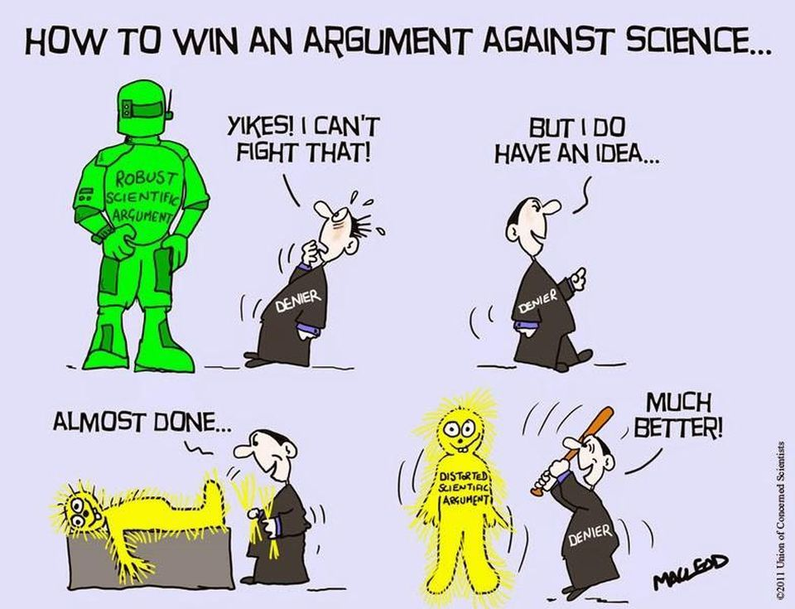10. Strawman argument – This happens when Person 1 misrepresents another person’s argument, so Person 1 can disprove it (instead of disproving the actual argument).

11. Two wrongs make a right. – This is used to justify doing something immoral or illegal to support one’s argument. If the other side did something bad, then my side can do something bad, too.

12. Whataboutism (or “tu quoque,” Latin for “you, too”) – This happens when a person refutes criticism of his/her position by saying that the opposing position also has problems.

**Want more information? Check out https://en.wikipedia.org/wiki/List_of_fallacies.**

This activity copyright 2021 Nelson Parish

Strawman cartoon: https://66.media.tumblr.com/7034abc1d33be1a0349361d82b463381/ff376624d39d90c2-fa/s1280x1920/f46759b166a878b14fb852939c4bac8f51b3ea00.jpg

 Look at the conversations below. Each one has a person using a fallacy while arguing. Which fallacy is being used in each conversation? Some conversations may have more than one fallacy.

H 10/6

B 11/12

**Which of the 12 fallacies is this one? 6**

Miss Big: I just don’t agree with the death penalty. I think there have been too many mistakes where innocent people were executed.

Mr. Bang: That’s a horrible idea! Could you imagine what would happen to our society if we didn’t punish murderers?

Miss. Big: That’s not what I said.

This activity copyright 2021 Nelson Parish Finish early: https://www.pinterest.co.kr/mindala95/fallacy/

Taxi driver: I noticed before you got in my car that you were smoking. You really shouldn’t do that. Studies show that smokers have a 50% higher chance of dying before they’re 65.

Passenger: Huh. Are you a doctor? No, you’re just a taxi driver. What do you know? Mind your own business.

I 5

G 1

F 3

E 3/4

D 2

C 9

A 8

Party A voter: Wow! Did you hear what President Obump did? He’s really corrupt! I can’t understand why you voted for him.

Party B voter: So what if he is corrupt? Most politicians are. Besides, you liked President Trama, and she was also corrupt. If your party can be corrupt, why can’t my party be corrupt, too?

Ms. Mool: Did you hear about Mr. Go? He killed himself last night!

Mr. Gee: That’s too bad. Hey, didn’t he win $100 million in the lottery a few months ago?

Ms. Mool: Yeah. I guess suddenly becoming rich makes people unhappy.

Mr. Fintin: I read a news story about your favorite actor, Jack Human. He’s been arrested for sexually assaulting many women. He’s apparently been doing it for years, and there’s a lot of evidence.

Ms. Limbim: It can’t be true. When I met him, he was a perfect gentleman. Also, he has a beautiful young wife, and he has given a lot of money to women’s charities. I don’t care what anyone says. I know he would never sexually assault anyone.

Mr. Moon: Did you hear about the latest mass shooting in the U.S.? The shooter had 10 guns! I don’t understand why it’s legal to own so many guns.

Ms. Uh: Well, the problem is if the government limits the number of guns you can own, pretty soon you won’t be able to own any guns at all – not even for hunting!

Bob: It’s obvious the ancient Egyptians had help building the Great Pyramids. Maybe aliens or the Egyptian gods helped them.

Bo: Why do you think that?

Bob: Well, how could they have built them? They didn’t have cranes and machines like we do these days. They must have had help.

Mr. Oh: I read an interesting article that said Elvis Presley is still alive and works as a skiing instructor in Canada. It was pretty believable, too.

Mrs. Jinguh: I don’t think so. Besides, he’d be in his 80s even if he were alive.

Mr. Oh: Yeah, but that doesn’t mean it couldn’t happen. Prove I’m wrong!

Speaker Kim: Well, to start off, my opponent’s position is that the Earth is round. Scientists have used alien technology to prove the Earth is flat. Everyone knows this – even the ancient Greeks knew it. This is the same alien technology that will allow us to visit the Sun within 10 years. My opponent knows this, but he won’t admit it.

Moderator: All right. It’s Bob’s turn to speak now. Bob, you have 30 seconds to tell us why you think the Earth is round.

Speaker Bob: Uh, well, I, uh.